

## DEPARTMENT OF COMPUTER ENGINEERING

**BRACT’S**

**VISHWAKARMA INSTITUTE OF INFORMATION TECHNOLOGY**

SURVEY NO. 3/4, KONDHWA (BUDRUK), PUNE – 411048, MAHARASHTRA (INDIA).

**BRACT’S**

**VISHWAKARMA INSTITUTE OF INFORMATION TECHNOLOGY, PUNE**

## 2022 -2023

**TY PROJECT-II REPORT ON**

Wardrobe Rizzz: Rizz up your Style

**TY.BACHELOR OF TECHNOLOGY (COMPUTER ENGINEERING)**

##### SUBMITTED BY

|  |  |  |
| --- | --- | --- |
| **STUDENT NAME** | **Gr. No.** | **Roll. No.** |
| Tejaswini Kulkarni | 22011114 | 324049 |
| Atharva Deo | 22010161 | 324058 |
| Kevin Jose | 22010038 | 324063 |
| Sahil Lodhe | 22010886 | 324067 |



**CERTIFICATE**

This is to certify that the project report entitles

**“Wardrobe** **Rizzz: Rizz up your Style”**

Submitted by

|  |  |  |
| --- | --- | --- |
| **STUDENT NAME** | **Gr. No.** | **Roll. No.** |
| Tejaswini Kulkarni | 22011114 | 324049 |
| Atharva Deo | 22010161 | 324058 |
| Kevin Jose | 22010038 | 324063 |
| Sahil Lodhe | 22010886 | 324067 |

is a bonafide student of this institute and the work has been carried out by him/her under the supervision of **Vikas K. Kolekar** and it is approved for the partial fulfillment of the requirement of VISHWAKARMA INSTITUTE OF INFORMATION TECHNOLOGY, for the award of the degree of **Bachelor of Technology** (Computer Engineering).

**Vikas K. Kolekar** **(Dr. S. R. Sakhare)**

Guide Head,

Department of Computer Engineering Department of Computer Engineering

Place : Pune

Date : 08-05-2023

**NAME OF THE STUDENTS**

**Tejaswini Kulkarni**

**Atharva Deo**

**Kevin Jose**

**Sahil Lodhe**

ACKNOWLEDGEMENT

We would like to express our gratitude and appreciation for the support that Vishwakarma Institute of Information Technology, Pune has provided to our group project on WardrobeRizz-Fashion AI. We would like to take this opportunity to acknowledge the assistance and guidance that we have received from Mr.Vikas Kolekar and Mr. Vikas Maral who have been instrumental in helping us to complete our project.

We would also like to express our appreciation for the resources and facilities that have been made available to us throughout the project. The use of the internet and access to the Library have been particularly helpful in our research and analysis.

Furthermore, we would like to extend our gratitude to the College for providing us with the opportunity to undertake this project. It has been an enriching and challenging experience that has enabled us to apply our knowledge and skills in a practical context, and we are grateful for the opportunity to work on a project that we are passionate about.

Once again, we would like to express our sincere appreciation for the support and guidance that we have received from Vishwakarma Institute of Information Technology, Pune. We are confident that the skills and knowledge that we have gained from this project will be invaluable to our future academic and professional pursuits.

Thank you for your support and encouragement throughout this project.

Sincerely,

Tejaswini Kulkarni

Atharva Deo

Kevin Jose

Sahil Lodhe

**ABSTRACT**

Our Fashion AI refers to the application of artificial intelligence (AI) technologies in the fashion industry. It involves the use of computer algorithms and machine learning techniques to analyze fashion trends, predict consumer behavior, optimize supply chain management, and enhance customer experience. Fashion AI can assist designers in creating new designs, retailers in recommending personalized outfits to customers, and manufacturers in streamlining production processes. By leveraging data and analytics, fashion AI has the potential to revolutionize the way the fashion industry operates, making it more efficient, sustainable, and customer centric. However, it also raises ethical and privacy concerns, particularly regarding the use of personal data and the potential displacement of human jobs.

With the advancement of technology, application areas of computer are rising day by day.

Every sector desires its procurement for fast accurate and automated operations. Therefore

different program are developed to meet the requirement of various types of users i.e. related to

any field

With the advancement of technology, application areas of computer are rising day by day.

Every sector desires its procurement for fast accurate and automated operations. Therefore

different program are developed to meet the requirement of various types of users i.e. related to

any field

SYSTEM

ABSTRACT

With the advancement of technology, application areas of computer are rising day by day.

Every sector desires its procurement for fast accurate and automated operations. Therefore

different program are developed to meet the requirement of various types of users i.e. related to

any field

TABLE OF CONTENTS

CHAPTER TITLE PAGE NO.

|  |  |  |  |  |  |
| --- | --- | --- | --- | --- | --- |
| **Sr. No.** | | **Title of Chapter** | | | **Page No.** |
| **I** | | **Introduction** | | | 6-10 |
|  | **I.1** | Overview | | | 6 |
|  | **I.2** | Motivation | | | 7 |
|  | **I.3** | Problem Definition and Objectives | | | 8 |
|  | **I.4** | Project Scope & Limitations | | | 9 |
| **II** | | Literature Survey | | | 11 |
| **III** | | Software Requirements Specification | | | 12 |
|  | **III.1** | Functional Requirements | | | 12 |
|  |  |  | System Feature 1(Functional Requirement) | |  |
|  |  |  | System Feature2 (Functional Requirement) | |  |
|  |  |  | …… | |  |
|  |  |  | …… | |  |
|  | **III.2** | External Interface Requirements (If Any) | | | 12 |
|  |  |  | User Interfaces | |  |
|  |  |  | Hardware Interfaces | |  |
|  |  |  | Software Interfaces | |  |
|  |  |  | Communication Interfaces | |  |
|  | **III.3** | Nonfunctional Requirements ( If any) | | | 12 |
|  |  |  | Performance Requirements | |  |
|  |  |  | Safety Requirements | |  |
|  |  |  | Security Requirements | |  |
|  |  |  | Software Quality Attributes | |  |
| **IV** | | System Design | | | 13-14 |
|  | **IV.1** | System Architecture | | | 13 |
|  | **IV.2** | Data Flow Diagrams | | | 14 |
| **V** | | Project Plan | | | 15 |
|  | **V.1** | Project Schedule | | | 15 |
|  |  | V.1.1 | | Project Task Set | 15 |
|  |  | V.1.2 | | Task Network | 15 |
|  | **V.2** | Team Organization | | | 15 |
|  |  | V.2.1 | | Team structure | 15 |
| **VI** | | Project Implementation | | | 16 |
| **VII** | | Results | | | 16-17 |
|  | **VII.1** | Screen Shots | | | 16 |
| **VIII** | | Conclusions | | | 18 |
|  | **VIII.1** | Applications | | | 18 |

1. **INTRODUCTION**
   1. **Overview**

A Fashion AI project typically involves the development and implementation of AI-based technologies and systems to solve specific challenges or enhance various aspects of the fashion industry. The project can be initiated by fashion brands, retailers, manufacturers, or startups, and typically involves collaboration with data scientists, software developers, and other experts in AI and fashion.

The project may start with identifying the specific problem or opportunity that the fashion industry is facing, such as inventory management, customer personalization, sustainability, or production efficiency. Then, the team may collect and analyze data from various sources, such as social media, sales history, and customer feedback, to train AI algorithms and models.

The AI technologies and systems developed in the project can include:

* Trend analysis and prediction: Using machine learning algorithms to analyze fashion trends, consumer behavior, and market data to identify emerging trends and predict future demand.
* Personalization: Developing AI-powered recommendation systems that can suggest personalized outfits to customers based on their preferences, purchase history, and other data.
* Production optimization: Using AI to optimize production processes, including inventory management, supply chain management, and quality control, to reduce waste and increase efficiency.
* Sustainability: Developing AI-powered solutions that can monitor and reduce the environmental impact of fashion production and consumption, such as reducing water usage, energy consumption, and carbon emissions.

Once the AI technologies and systems are developed, they need to be tested and validated through pilot projects and user feedback. The project team may also need to address ethical and privacy concerns related to the use of personal data and the potential impact on human jobs.

Overall, a Fashion AI project can provide significant benefits to the fashion industry, including increased efficiency, sustainability, and customer satisfaction. However, it requires careful planning, collaboration, and ongoing evaluation to ensure its success.

* 1. **Motivation**

There are several motivations for choosing a Fashion AI project, including:

Improving efficiency: The fashion industry is highly competitive, and companies need to constantly innovate to stay ahead. Fashion AI can help companies optimize various processes, such as inventory management, supply chain management, and production planning, to reduce costs and increase efficiency.

Enhancing customer experience: Today's consumers are looking for personalized experiences when shopping for fashion. Fashion AI can help retailers and brands offer personalized recommendations to customers based on their preferences and purchase history, leading to a more satisfying shopping experience.

Promoting sustainability: The fashion industry is known for its environmental impact, from excessive water usage to garment waste. Fashion AI can help companies monitor and reduce their environmental footprint, for example, by optimizing production processes or reducing waste in the supply chain.

Advancing technology: Fashion AI is an exciting field that combines cutting-edge technologies such as computer vision, natural language processing, and machine learning. Developing Fashion AI projects can help advance the field and contribute to the development of new AI applications in the fashion industry.

Meeting consumer demands: Consumers are increasingly aware of the impact of fashion on the environment and are demanding more sustainable and ethical practices from companies. Fashion AI can help companies meet these demands and build trust with consumers by offering transparency in their processes and products.

Overall, a Fashion AI project can provide a range of benefits, from improving efficiency to enhancing customer experience and promoting sustainability. It is a rapidly growing field with exciting opportunities for innovation and impact in the fashion industry.

* 1. **Problem Definition and Objectives**

Problem Definition:

The fashion industry faces several challenges that can be addressed through Fashion AI. These challenges include:

* Lack of personalization: Consumers today expect personalized experiences when shopping for fashion, but many retailers and brands struggle to offer this level of customization due to the sheer volume of data they need to process.
* Inefficient supply chain: The fashion industry's supply chain can be complex and inefficient, leading to issues such as overproduction, stockouts, and waste.
* Slow response to trends: The fashion industry is known for being slow to respond to emerging trends, which can lead to missed opportunities and lost sales.
* Environmental impact: The fashion industry is one of the most polluting industries globally, with significant environmental impact from production processes, waste, and carbon emissions.

Objectives:

The objectives of a Fashion AI project can include:

* Personalization: Developing AI-powered recommendation systems that can suggest personalized outfits to customers based on their preferences, purchase history, and other data.
* Supply chain optimization: Using AI to optimize production processes, including inventory management, supply chain management, and quality control, to reduce waste and increase efficiency.
* Trend analysis and prediction: Using machine learning algorithms to analyze fashion trends, consumer behavior, and market data to identify emerging trends and predict future demand.
* Sustainability: Developing AI-powered solutions that can monitor and reduce the environmental impact of fashion production and consumption, such as reducing water usage, energy consumption, and carbon emissions.

Overall, the objectives of a Fashion AI project aim to address the challenges facing the fashion industry and provide solutions that improve efficiency, enhance customer experience, and promote sustainability.

* 1. **Project Scope & Limitations**

Project Scope:

The scope of a Fashion AI project can vary depending on the specific problem or opportunity being addressed. However, some typical areas that a Fashion AI project can cover include:

* Data collection and analysis: Collecting and analyzing data from various sources such as social media, sales history, and customer feedback to train AI algorithms and models.
* AI technology development: Developing AI technologies and systems that can address specific challenges or opportunities in the fashion industry, such as personalization, supply chain optimization, trend analysis and prediction, sustainability, and virtual try-on and fitting.
* Pilot projects and validation: Testing and validating AI technologies and systems through pilot projects and user feedback to ensure they meet the desired objectives.
* Ethical and privacy considerations: Addressing ethical and privacy concerns related to the use of personal data and the potential impact on human jobs.

The future scope of Fashion AI is vast, as it is a rapidly evolving field with new technologies and applications emerging constantly. Some potential future directions for Fashion AI include:

* Enhanced personalization: As AI technologies continue to advance, they can provide more accurate and personalized recommendations to customers, taking into account not only their purchase history but also their style preferences, body type, and even their location and weather conditions.
* Extended virtual try-on and fitting: Virtual try-on and fitting technologies are becoming more sophisticated, allowing customers to see how clothes look on their body in real-time and in various lighting conditions. In the future, virtual try-on and fitting could be extended to include accessories, makeup, and even hairstyles.
* Sustainability optimization: As sustainability becomes an increasingly important concern in the fashion industry, Fashion AI can help companies reduce their environmental impact by optimizing production processes, reducing waste, and developing new materials and techniques.
* Improved supply chain efficiency: AI can help optimize the fashion supply chain, improving efficiency and reducing costs. In the future, AI technologies could be used to track and monitor the entire supply chain in real-time, allowing companies to respond quickly to changes in demand and supply.
* Integration of AR and VR technologies: Augmented reality (AR) and virtual reality (VR) technologies are already being used in the fashion industry, but their use is expected to grow in the future. AR and VR technologies can be used to create immersive shopping experiences and virtual fashion shows, allowing customers to see how clothes move and fit in a realistic 3D environment.

Overall, the future of Fashion AI is exciting, with new technologies and applications emerging constantly. By leveraging AI, the fashion industry can create more personalized and sustainable experiences for customers, optimize supply chains, and stay ahead of emerging trends.

Limitations:

There are also some limitations to Fashion AI projects, including:

* Data quality and availability: Fashion AI relies heavily on data, and poor data quality or availability can limit the accuracy and effectiveness of AI technologies and systems.
* Cost and resource constraints: Developing and implementing AI technologies and systems can be costly and resource-intensive, which can limit the scope and scale of Fashion AI projects.
* Ethical and privacy concerns: The use of personal data and the potential impact on human jobs raise ethical and privacy concerns that need to be carefully considered and addressed.
* Human creativity and intuition: While AI can provide valuable insights and predictions, it cannot replace human creativity and intuition, which are critical in the fashion industry.

Overall, Fashion AI projects have a significant potential to address challenges and opportunities in the fashion industry, but they also have limitations that need to be considered and managed effectively.

1. **Literature Survey**

Fashion AI is a rapidly evolving field, and there has been a growing body of research and literature in recent years. Here are some of the key research papers and articles related to Fashion AI:

* **"FashionAI: A Clothing Style-Based Recommendation System for Online Fashion Shopping"** by Jianlong Fu et al. This paper proposes a recommendation system that utilizes deep learning techniques to provide personalized fashion recommendations based on clothing style.
* **"FashionGAN: Deep Learning-based Fashion Image Synthesis with Augmentation"** by D. R. Baek et al. This paper proposes a method for generating high-quality fashion images using Generative Adversarial Networks (GANs) and data augmentation techniques.
* **"A Survey of Fashion Recommendation Systems and Future Directions"** by F. T. Soleymani et al. This survey paper provides an overview of the existing fashion recommendation systems and highlights the challenges and opportunities in this field.
* **"DeepFashion: Powering Robust Clothes Recognition and Retrieval with Rich Annotations"** by Z. Liu et al. This paper proposes a large-scale clothing recognition and retrieval system using deep learning techniques and rich annotations.
* **"Virtual Fitting: A Review of Recent Developments and Future Directions"** by J. Park et al. This paper provides an overview of the recent developments in virtual fitting technology, including 3D scanning and modeling, computer vision, and augmented reality.
* **"The Future of Fashion: From Design to Retail, How Tech Is Reshaping the Industry"** by Vogue Business. This article provides an overview of how Fashion AI is transforming the fashion industry, including personalized recommendations, supply chain optimization, and virtual try-on technologies.

Overall, Fashion AI highlights the potential of AI technologies in the fashion industry, including personalized recommendations, virtual try-on and fitting, and supply chain optimization. However, there are also challenges and limitations, such as data quality and privacy concerns, that need to be addressed to fully realize the potential of Fashion AI.

1. **Software Requirements Specification**
   1. **Functional Requirements**
2. **Login Functionality**

We have added a login functionality to the website which can provide numerous benefits, such as improving security, enabling personalized experiences for users, and allowing users to save and access their data across different devices.

1. **Files Uploading Functionality**

We have added file uploading functionality to the website which is a common feature that enables users to upload files such as images to the Firebase Storage.

* 1. **External Interface Requirements**

1. **News API**

A News API (Application Programming Interface) is a platform that allows developers to access news data from a variety of sources, such as news websites, blogs, and social media platforms. News APIs provide structured data that can be used to build news applications or integrate news content into existing applications. We have used a similar one in terms of giving us the latest fashion trends in order to make the website more informative.

* 1. **Nonfunctional Requirements**

**None**

1. **System Design**
   1. **System Architecture**

The system architecture for Fashion AI can vary depending on the specific application and requirements, but here is a general overview of the components that may be included:

* Data Collection: The first step in developing a Fashion AI system is to collect data from various sources. This can include product information, customer data, social media data, and other relevant data sources.
* Data Pre-processing: Once the data is collected, it needs to be pre-processed and cleaned to ensure that it is accurate and usable. This can include tasks such as data normalization, data cleaning, and data transformation.
* Feature Extraction: After the data is pre-processed, features need to be extracted from it. This involves identifying the most relevant attributes and characteristics of the data that can be used for analysis and modeling.
* Model Development: Using machine learning algorithms, models can be developed that can analyze the extracted features and provide recommendations or predictions. The specific type of model will depend on the application, but common models include collaborative filtering, content-based filtering, and hybrid models.
* Integration with Front-end: Once the model is developed, it needs to be integrated with the front-end interface of the Fashion AI system. This can include developing a web application, mobile application, or other interfaces that allow users to interact with the system.
* Deployment and Monitoring: The final step is to deploy the Fashion AI system and monitor its performance. This can involve ongoing model updates, data retraining, and performance monitoring to ensure that the system continues to provide accurate and relevant recommendations to users.

Overall, the system architecture for Fashion AI is complex and requires expertise in data science, machine learning, and software engineering. However, with the right approach and expertise, Fashion AI can provide significant value to the fashion industry and revolutionize the way that customers shop for clothes.

* 1. **Data Flow Diagrams**

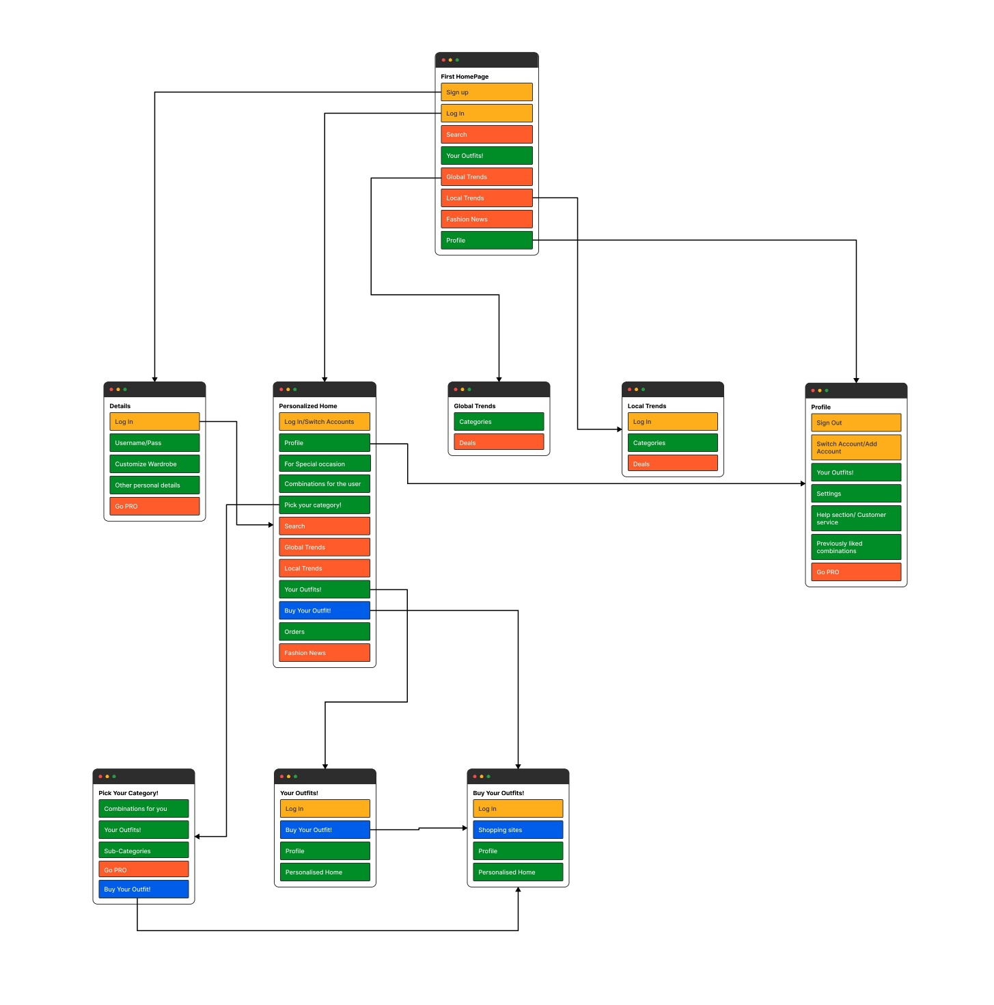

1. **Project Plan**
   1. **Project Schedule**
      1. **Project Task Set**

* Style Recommendation: Create a recommendation engine that suggests outfits based on personal preferences, body type, occasion, and weather. The AI system can use historical data to suggest items that the user has previously purchased or liked.
* Sustainable Fashion: Develop an AI system that can help users make more sustainable fashion choices by recommending eco-friendly and ethically-made products, and providing information on the environmental impact of fashion items.
  + 1. **Task Network**
* Data Collection: Collect and curate a large dataset of fashion images and metadata, including information on style, color, pattern, and texture.
* Personalization: Use customer data, including previous purchase history, browsing behavior, and body measurements, to personalize recommendations and suggestions.
* Style Recommendation: Develop a recommendation engine that suggests outfits based on personal style preferences, occasion, weather, and other relevant factors.
* Trend Analysis: Use data analysis techniques to predict and track fashion trends, including social media trends and customer preferences.
* Sustainability: Incorporate sustainability criteria into the recommendation engine, providing information on eco-friendly and ethically made products and reducing the environmental impact of fashion.
* Feedback Loop: Continuously gather feedback from customers to improve the AI system's performance, accuracy, and effectiveness.
  1. **Team Organization**
     1. **Team structure**

**Tejaswini Kulkarni:** Carousel

**Atharva Deo:** News API

**Kevin Jose:** Login-Logout Functionality, Designing, Documentation

**Sahil Lodhe:** Dropbox to upload pictures to Firebase Storage

1. **Project Implementation**

We have implemented a News API to shows the latest trends on fashion.

We have created a Login-Logout page for users.

We have created a drop box for uploading pictures of clothes to firebase storage.

1. **Results**
   1. **Screen Shots**

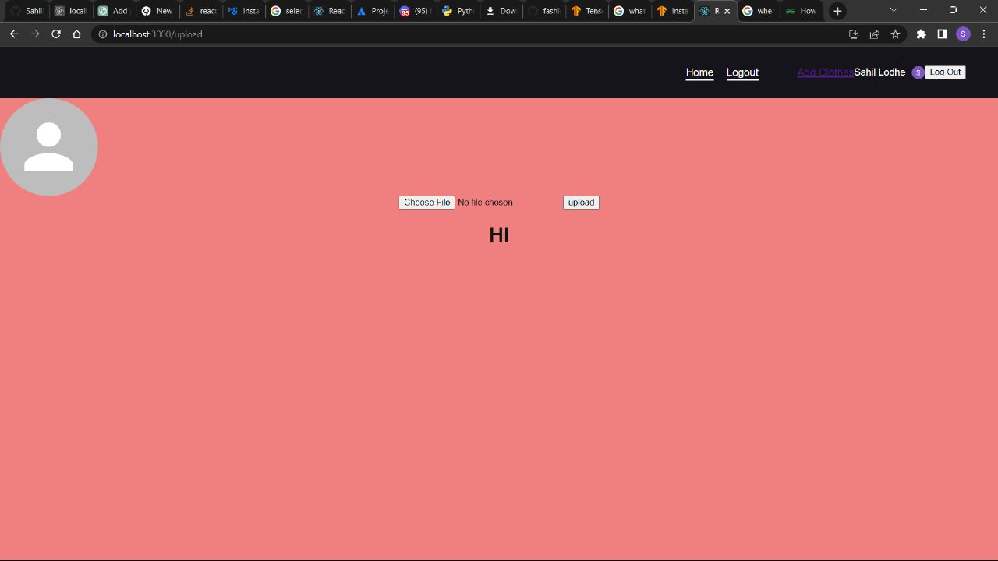

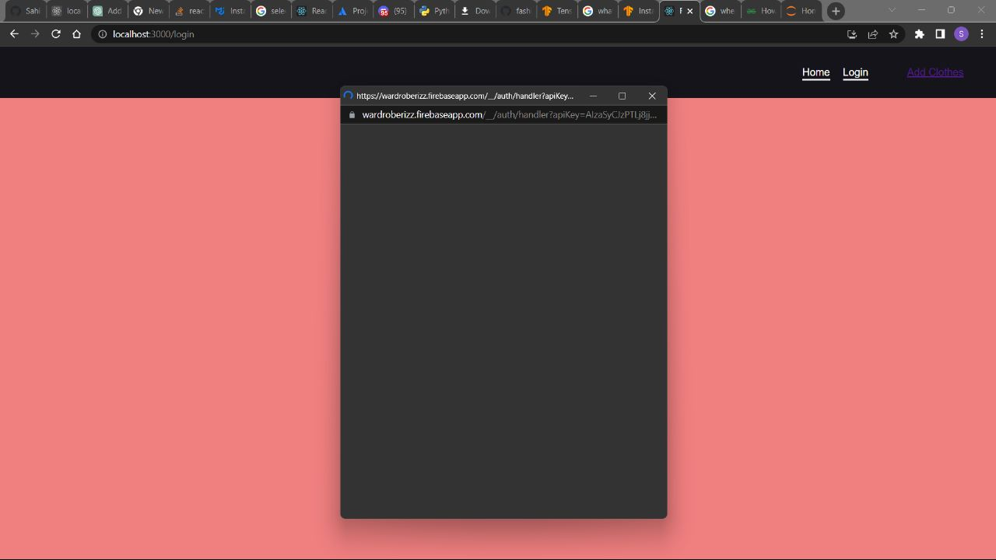

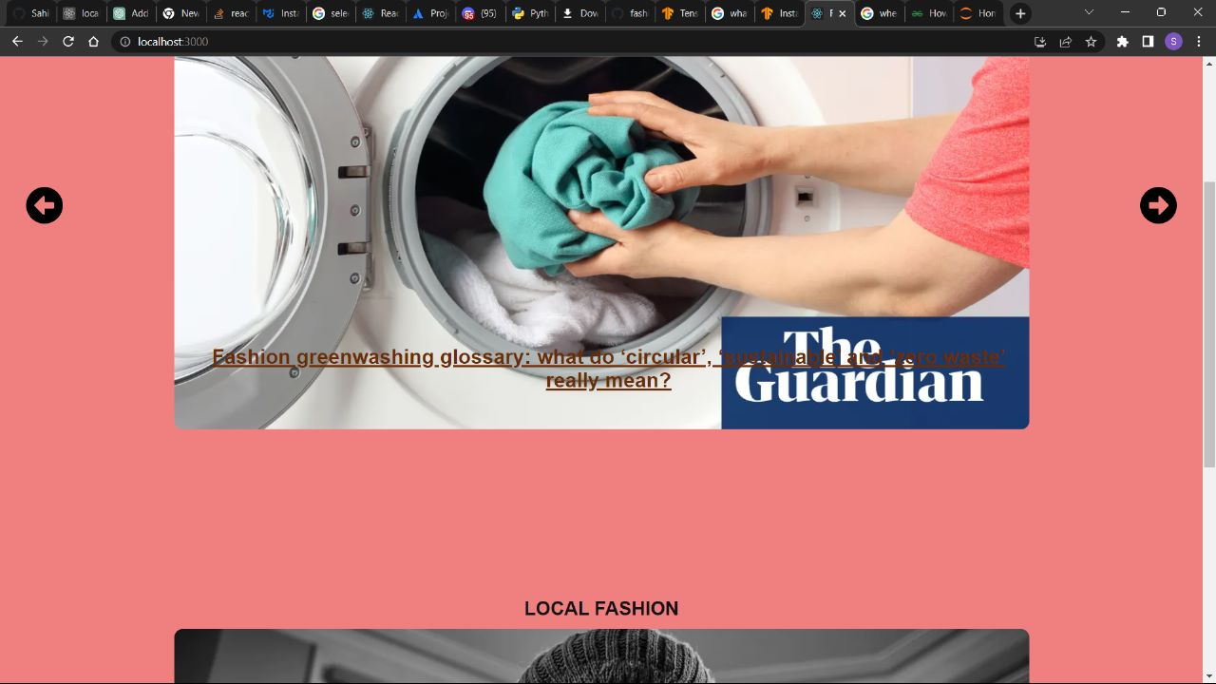

1. **Conclusion**
   1. **Applications**

Fashion AI has a wide range of applications across the fashion industry. Here are some of the key applications of Fashion AI:

* Image and pattern recognition: AI can be used to recognize patterns in fabrics, analyze colors and textures, and identify specific garment styles or types. This can help designers and retailers to create new products and improve their inventory management.
* Virtual Try-On: AI can be used to create virtual try-on experiences, allowing customers to see how clothes will look on them before making a purchase. This can increase customer satisfaction and reduce the need for physical try-on rooms.
* Product design and manufacturing: AI can be used to assist with product design and manufacturing, by generating designs and creating 3D models that can be used in the production process. This can reduce the time and cost involved in creating new products.
* Personalized recommendations: AI can be used to analyze a customer's preferences and suggest personalized fashion items that they are likely to be interested in. This can increase sales and improve customer satisfaction.
* Trend forecasting: AI can be used to analyze social media, fashion blogs, and other sources of data to identify emerging trends in the fashion industry. This can help designers and retailers to stay ahead of the curve and create products that are more likely to be in demand.
* Supply chain optimization: AI can be used to optimize the fashion supply chain, by predicting demand and ensuring that the right products are available at the right time. This can reduce waste and improve sustainability.

Overall, Fashion AI has the potential to revolutionize the fashion industry by improving the customer experience, increasing sales, reducing waste, and improving sustainability. By leveraging the power of AI, designers and retailers can create more personalized and sustainable products, while also reducing the time and cost involved in product design and manufacturing.